Report for: | Cabinet
Date of Meeting: | 16 November 2023
Subject: | Harrow Long Term Transport Strategy: Draft for public consultation.
Key Decision: | Yes, affects multiple wards and over time will be significant in terms of its impact on our communities.
Responsible Officer: | Dipti Patel, Corporate Director for Place  Cathy Knubley Director Environment
Portfolio Holder: | Councillor Anjana Patel, Portfolio Holder for Highways, Infrastructure and Community Safety
Exempt: | No
Decision subject to Call-in: | Yes
Wards affected: | All
Enclosures: | Appendix 1 – Harrow Long Term Transport Strategy  Appendix 2 - EQIA

Section 1 – Summary and Recommendations
This report presents a draft Harrow Long Term Transport Strategy for approval for public consultation.

Recommendations:
Cabinet is requested to:
1. Approve the draft Transport Strategy for public consultation

2. Note that the results of public consultation will be considered and reported back to Cabinet with the final Strategy for approval in principle.

3. Refer the results of the public consultation and final Strategy to full Council for final approval.

Reason: (for recommendations)
This Long-Term Transport Strategy (LTTS) provides strategic direction for all aspect of transport withing the London Borough of Harrow over the next 20 years. This is the first Strategy of this kind for the Borough and sets out the Council’s ambitions for a transport system that is more accessible, safer and greener, whilst recognising that cars will always be a vital link in the chain. This Strategy can help to address transport aspects through meaningful actions.

Section 2 – Report

Introductory paragraph

The Borough requires this Strategy to identify what needs to change in order to achieve our vision. Without the evidence and clear objectives, Harrow lacks the rationale for change in the Borough and delivery of actions that are needed to create a cleaner, safer and greener Borough, whilst still meeting the needs of our residents and their cars. With the Strategy, the Council can show commitment to playing a leading part in responding to the climate emergency and setting out a clear pathway of action and engagement over the next 20 years. These actions are fundamental to tackling the key challenges and ensuring everyone can benefit.

The Strategy looks beyond the present day to 20 years in the future. It is far enough into the future to allow time for major changes to transport infrastructure and policy, while still allowing for immediate challenges to be addressed in the short term. Delivery of interventions across the next two decades allows us to consider the longer term political, economic, social, technological and environmental changes that influence the way we currently live, work and travel as well as how we will do so in the future.

Options considered

Do nothing: this option is not recommended as this strategy will be used to improve the management of movements into and through Harrow in the short and longer term, meeting the needs of our residents. This will help the Borough to address current barriers that affect the movement of people and goods and offer up benefits that are currently not available or limited.

Agree the draft Harrow Long Term Transport Strategy for consultation: to provide a long-term strategic framework for action both as an organisation and a borough.

Background

.Harrow is an outer-London borough with a strong identity and close-knit communities. It offers plentiful green space while hosting bustling town centres with fast and frequent links into Central London. Harrow is also a diverse borough, with each neighbourhood having a unique set of transport challenges and opportunities including those which relate to connections to neighbouring local authorities. The summary picture below provides information of the Borough

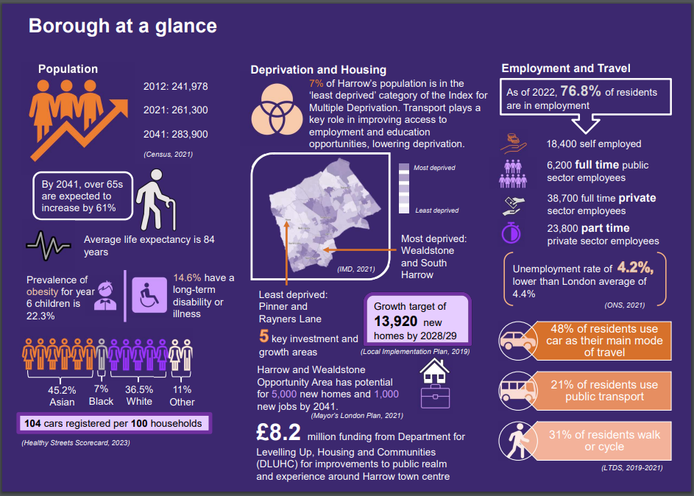

What does the Strategy do?

The Strategy will focus on the critical challenges facing Harrow, including a rapidly growing population, and the need to improve safety and accessibility of all types of transport. We recognise the need for car usage in our Outer London Borough, the need to electrify transport and increase options for attractive and accessible travel by foot, cycle and public transport for those residents that wish to use these methods. People need to feel safe to walk, cycle and use sustainable modes of transport. The Strategy is vision-led and is built on what exists in the Borough today, and where there are opportunities to change things for a more sustainable and healthier future. The Strategy is aligned with local, national and regional policy direction and targets, the evidence base highlights where there is a need for change, and the action plans identify what exactly can change, how and when.

Overview of the draft Strategy

Our Vision:

Harrow is committed to creating more pleasant neighbourhoods and town centres with better improved accessibility and sustainable travel opportunities for all. Harrow will work towards achieving the vision for a more accessible, safer and greener transport system, whilst recognising the need for car usage. Travel in Harrow will be designed and integrated around communities to support everyday journeys and drive long-term sustainable growth. The public transport and active travel networks will be attractive alternatives alongside private vehicles, whilst more people will switch to driving electric vehicles, reducing carbon emissions. Those travelling through the borough will be offered healthier and greener choices. This will support the borough’s mission to ensure infrastructure is resilient to climate change, and secure Harrow’s long-term status as an attractive place for residents, workers and visitors.

This vision is underpinned by four ambitions as shown in the table extract below. Beneath these sit our nine key priorities, these encompass different modes of transport and frame our action plans. Our actions include a range of policies, partnerships and interventions for the Council to consider.
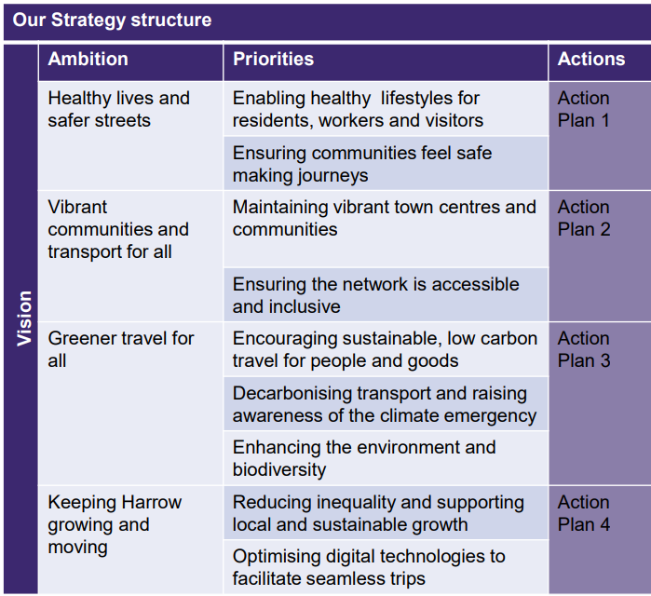
The Strategy consists of the following chapters:
- Executive Summary
- Introduction
- Understanding Harrow Today
- Guiding Principles for the Strategy
- Our Ambitions
- Ambition 1 – Healthy Lives and Safer Streets
- Ambition 2 – Vibrant Communities and Transport for All
- Ambition 3 – Greener Travel Options
- Ambition 4 – Keeping Harrow Moving and Growing
- Making it Happen

Implications of the Recommendations

Environmental Implications
Environmental implications are integral to the subject matter of this report.

Risk Management Implications

Risks included on corporate or directorate risk register? No

Separate risk register in place? No

The relevant risks contained in the register are attached/summarised below. Yes

The following key risks should be taken into account when agreeing the recommendations in this report:

Risk Description | Mitigations | RAG Status
Without a Long-term Transport Strategy (LTTS) the Council’s overall strategic vision of Restoring Pride in Harrow will not be supported by a parallel transport strategy that will be vital to the achievement of this overall vision for the borough | Formulate and implement a Long-Term Transport Strategy (LTTS) as proposed in this report | GREEN
Without an LTTS, there is a risk that the councils transport network will not be able to respond to changes in the environmental, economic, health and social context. In understanding this, it allows the Harrow transport network to evolve in response to this for the benefit of users. | Formulate and implement an LTTS as proposed in this report | GREEN
Without an LTTS, there is a danger that future Plans, Policies, Strategies and Projects will not realise their full benefits and potential. | Formulate and implement an LTTS as proposed in this report | GREEN
A LTTS is often a prerequisite when applying for external funding for transport projects. Therefore having a new LTTS will help shape the Councils future and investment decisions and prove critical in attracting external funding. | Formulate and implement an LTTS as proposed in this report | GREEN
Not having an LTTS gives residents, visitors and investors the impression that Harrow does not care about its transport network and might discourage them from wanting to live in, work in and visit Harrow. | Formulate and implement an LTTS as proposed in this report | GREEN
Not having an LTTS could compromise the Council’s abilities to hit Net Zero, air quality and noise quality targets. | Formulate and implement a LTTS as proposed in this report | GREEN

Risk Description | Mitigations | RAG Status
Arrangements entered into for public consultation on the strategy (incl. for logistics and publicity of the consultation exercise itself) are not adequate or effective | - The consultation will be undertaken via designated web site portal MyHarrowTalk (EngagementHQ)  - The consultation will be publicised via LBH website  - Hard copies in libraries  - Email and letter notifications to stakeholders  - Social media  - Survey | GREEN
Key stakeholders in the consultation (such as residents, businesses or interest groups) have not been identified or made a focus for the consultation | - Key stakeholders include  - members  - All departments in the Council  - Businesses  - Residents  - Protected characteristic groups  - Environmental groups  - Schools/educational establishments  - Emergency services | GREEN
The consultation exercise has not been resourced adequately | - Designated team in place for the consultation of approx. up to 6 people (consisting of project team members) that can be deployed if necessary to address and process consultation feedback | GREEN
The number and substance of responses expected to be made in the consultation has not been adequately anticipated | - Our expectation of the number of respondents is at least 150 | GREEN
Feedback from the consultation exercised is not fully captured | - Website responses are recorded in Engagement HQ and other responses will be manually recorded | GREEN
Feedback from the consultation is not shared with residents and respondents and is also not appropriately acted upon | - Results of the consultation will be made public and fully shared via update on the web portal | GREEN

Procurement Implications
Although the strategy will not require procurement, any project initiated through enacting the strategy will require and undertake the full procurement process.

Legal Implications
Article 3 (The Full Council) of the Council’s Constitution sets out the functions that are reserved for decision by the full Council. This includes responsibility for approving the policy framework. The plans and strategies included in the meaning of ‘policy framework’ are listed in Paragraph 3.1(a) (i) of Article 3 and includes Local Implementation Plan.

The Strategy will directly feed into the Council’s Fourth Implementation Plan. The Strategy states that: -

“This Strategy is a driver to assist the Council in the production of its next and fourth Local Implementation Plan.”
“This Strategy will bridge the gap between the London-wide priorities of the Mayor’s Transport Strategy and Harrow’s Local Implementation Plan.”
“The action plans of this Strategy will be taken forwards to the next and fourth Local Implementation Plan (LIP) that will be developed in 2024.”

Therefore, the Strategy should be subject to final approval from Full Council in accordance with Article 3 of the Constitution.

There are no direct legal implications associated with considering this report. Any proposals or projects arising from the LTTS will be detailed in future reports and will include the relevant legal implications.

Financial Implications
Any costs associated with the public consultation of the Transport Strategy will be met within Highway Services.

The draft Transport Strategy in Appendix 1 outlines a number of proposed measures under each of the nine key priorities, the delivery leads of which consist of both the Council and external parties such as Transport for London and London Metropolitan Police. The delivery of these measures will require significant investment. While the Transport Strategy itself does not commit to any spending, the work programme that will be developed to deliver the measures will have financial implications. Funding sources will need to be identified alongside the development of the work programme to ensure that the costs of any proposed works are fully funded.

Equalities implications / Public Sector Equality Duty
A draft Equalities Impact Assessment (EQIA) has been prepared which considers the impact of transport and future changes upon those with protected characteristics. Elderly, disabled and those who are pregnant are currently more reliant upon vehicular transport than the population at large, and this will remain the case over coming years. Young people are also likely to significantly benefit from air quality and active travel improvements. Reduced congestion along with improvements to accessibility, air quality and road safety benefit all groups to varying degrees. Targeted engagement along with monitoring and evaluation will help to establish the likely impacts of measures which will lead to better suited, and better used schemes.

The draft EQIA will be kept under review and updated where necessary in light of consultation feedback.

Council Priorities
The interaction of the Healthy Streets key outcomes and the connection to our Transport Strategy ambitions, support the Council’s overarching commitment to Restoring Pride in Harrow. To help everyone understand what we want to achieve for Harrow and how we plan to do this, the Council’s three priorities are reflected throughout this document:

- A council that puts residents first
- A place that is clean and safe
- A borough that supports those in need

Section 3 - Statutory Officer Clearance
Statutory Officer: Jessie Man
Signed on behalf of the Chief Financial Officer
Date: 8/11/23
Statutory Officer: Patricia Davila
Signed on behalf of the Monitoring Officer
Date: 8/11/23
Chief Officer: Dipti Patel
Signed by the Corporate Director
Date: 10/11/23
Head of Procurement: David Hayes
Signed on behalf of the Head of Procurement
Date: 8/11/23
Head of Internal Audit: Neale Burns
Signed on behalf of Head of Internal Audit

Date: 8/11/23

Has the Portfolio Holder(s) been consulted? Yes ☒

Mandatory Checks

Ward Councillors notified: NO as it impacts on all Wards

EqIA carried out: YES

Section 4 - Contact Details and Background Papers
Contact:
Dalton Cenac / Interim Head of Traffic, Highways and Asset Management dalton.cenac@harrow.gov.uk
Background Papers: None
Call-in waived by the Chair of Overview and Scrutiny Committee - NO

